Bipolar junction transistor as an audio amplifier

Hamish Sams
EEE160
Collaborator : Chun Lo

Contents
Contents
Contents 1
Introduction 2
Theory 2
Method 3
Results – Output characteristic 5
Graphs 6
Results – Transfer/Input characteristic 8
Calculations 11
Discussion 13
Errors 14
Conclusion 15
References 16

Introduction

This report discusses the BJT (Bipolar Junction Transistor) specifically the BC549 B, which is an NPN type, for use as an audio amplifier through a set of experiments. The objective of this report is to obtain a deeper understanding of the use of a BJT as a signal amplifier this could be used for many applications such as an audio amplifier, it would be helpful to define a series of equations or graphs to reference for future projects to find the gain at certain operating points.

Theory

A BJT is one of the only types of transistor that operates through both electrons and holes to operate. In this report an NPN version is used where the emitter is very heavily N doped, base is p doped and collector is heavily n doped(fig 1). As of these dopings 2 depletion regions are setup meaning current cannot flow from emitter to collector without a voltage applied to the base, when a voltage is applied to the base the emitter and collector can start conducting with a direct proportionality to the signal applied to the base assuming $V_{ce}$stays constant. This means the BJT is often used in amplifiers to boost a signals strength so a small signal can run a resistive load like a speaker. But as of the bias on the base the BJT can be used as an electronic switch to avoid a signal “floating”.
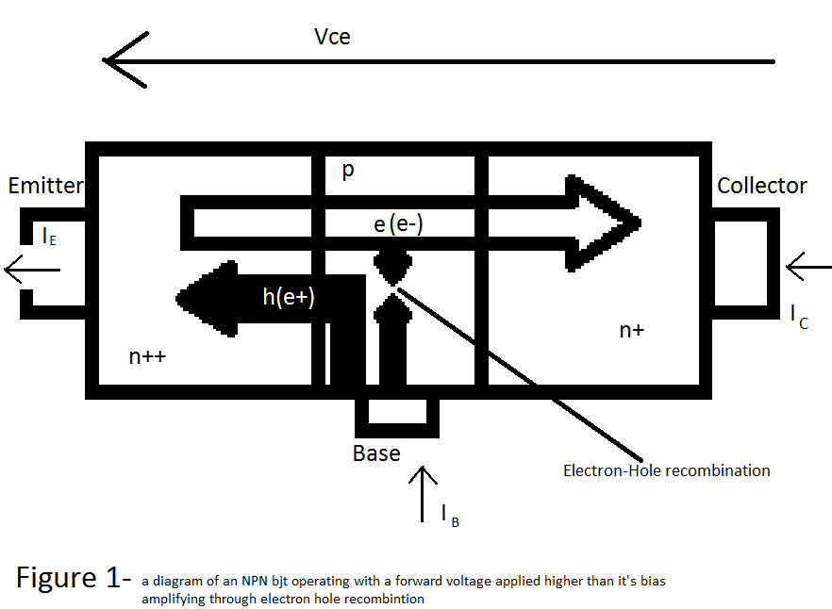
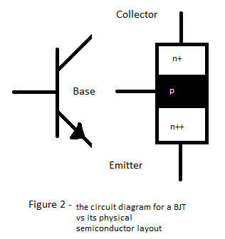

Method

To begin the circuit in figure 3 was set up with an NI Elvis multimeter measuring the $V_{ce}$[1], a Tenema multimeter[2] measuring the $I_{c}$ and finally the Agilent bench multimeter[3] Measuring $I_{b}$ (These currents and voltages can be seen on figure 1 and 2).
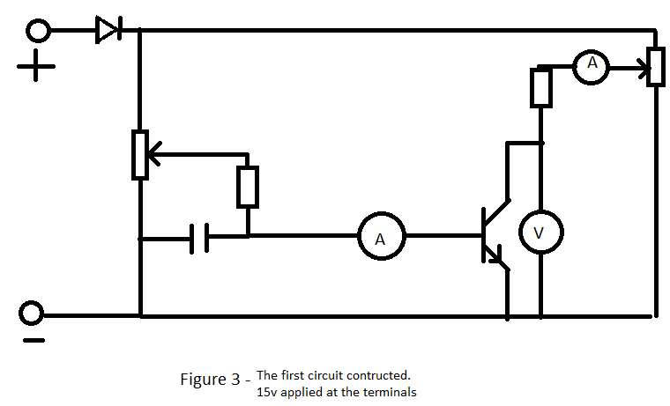
The circuit is then powered by a constant 15V dc supply from a Keysight PSU [4]. After this results can be taken by varying the potentiometers(left) setting $I_{b}$at a constant value throughout the results and stepping up the value of $V_{ce}$by varying the second potentiometer (right). The value for $I_{c}$ is then written down for these steps of $V_{ce}$. When those results are done the value of $I_{b}$is then increased and the process is repeated until all results are obtained.

Next a voltmeter is added to the circuit as shown below (figure 4) in this case another Tenema multimeter[2] used to measure $V_{ce}$ and the NI Elvis multimeter[1] was moved to measure $V_{be}$.
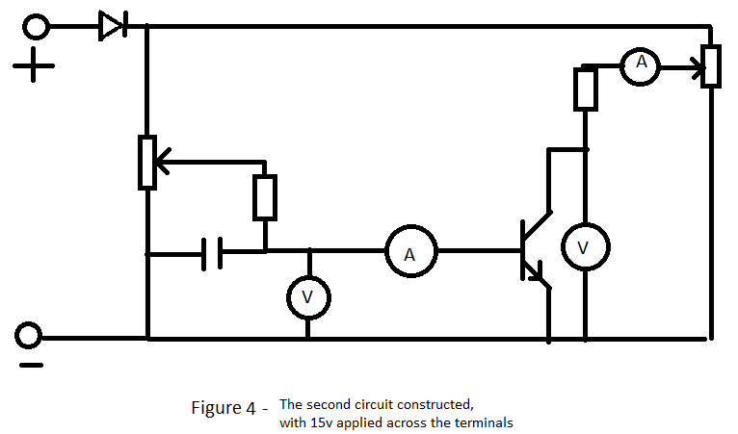
The circuit is again powered by a 15V dc supply [4] , The potentiometers are used this time to keep$V_{ce}$ constant and this time $I_{c}$ is increased in steps with $I_{b}$and $V_{be}$measured. Making sure that $V_{ce}$ isn’t too large so that the transistor heats up and alters the transistors response.
After these the best values of resitances for the audio amplifier can be calculated and therefore are ready to make the amplifier circuit. These resistances can then be added to the circuit as shown below (figure 5)
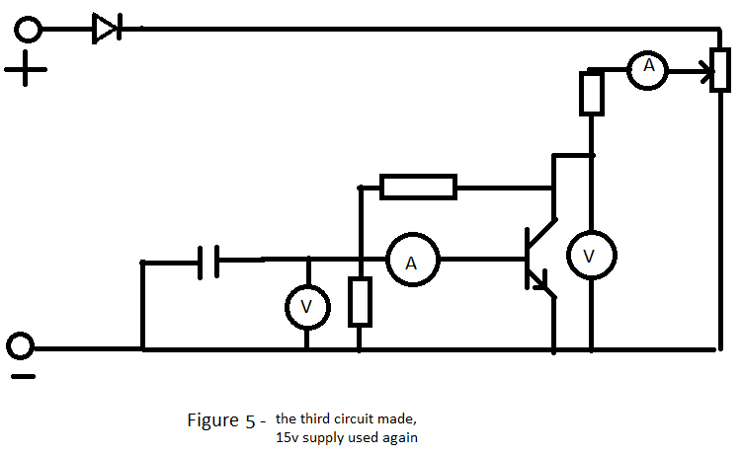
With the same power supply[4] Set the value of $V_{ce}$ to 7.5v and measure the values of $V_{be}$,$I_{b}$and $I_{c}$
This is then used to check values against that of the calculations.
The circuit below(figure 6) is now made.
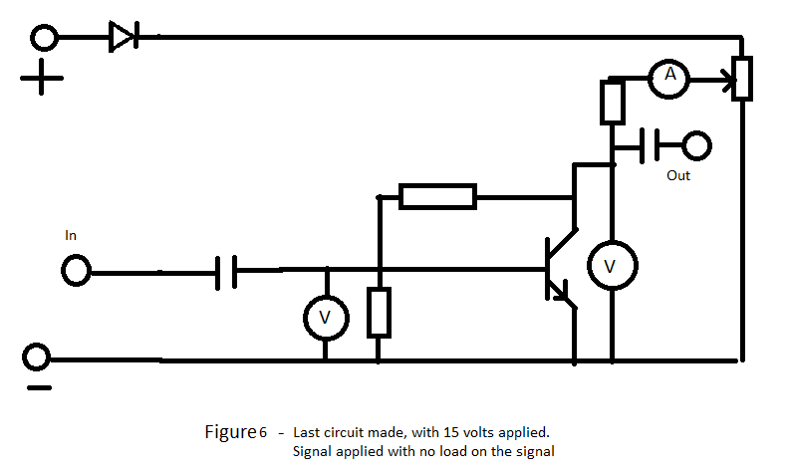
A signal of 10kHz is now applied on the signal input , set this at around 15mV and alter until the signal out is around 2V peak to peak, this was measured by a keysight oscilloscope [5]. Now the values of $V_{in}$($V_{be})$and$V_{out}$($V_{ce})$ should be noted down to find the gain which can be compared to the calculated. It may also be of use to look at the phase difference of input to output.
After testing with no load the same circuit with a speaker in should be tested noting down $V_{in}$($V_{be})$and$V_{out}$($V_{ce})$ again to see the gain this time. Make sure to measure the resistance of the speaker used.

Results – Output characteristic
Ib(uA) | Vce(V) | Ic(mA)
5.00 | 0.00 | 0.00
5.00 | 0.05 | 0.18
5.00 | 0.10 | 1.01
5.00 | 0.50 | 3.37
5.00 | 1.00 | 3.35
5.00 | 4.00 | 3.56
5.00 | 7.00 | 3.75
5.00 | 11.00 | 3.84
5.00 | 13.00 | 3.95
Ib(uA) | Vce(V) | Ic(mA)
10.00 | 0.00 | 0.00
10.00 | 0.05 | 0.38
10.00 | 0.10 | 1.98
10.00 | 0.50 | 6.66
10.00 | 1.00 | 6.70
10.00 | 4.00 | 7.09
10.00 | 7.00 | 7.42
10.00 | 11.00 | 7.93
[B]
[A]

Ib(uA) | Vce(V) | Ic(mA)
15.00 | 0.00 | 0.00
15.00 | 0.05 | 0.57
15.00 | 0.10 | 2.52
15.00 | 0.50 | 9.84
15.00 | 1.00 | 9.95
15.00 | 4.00 | 10.58
15.00 | 7.00 | 11.09
15.00 | 11.00 | 12.18
Ib(uA) | Vce(V) | Ic(mA)
20.00 | 0.00 | 0.00
20.00 | 0.25 | 10.88
20.00 | 0.50 | 12.88
20.00 | 0.75 | 13.10
20.00 | 1.00 | 13.18
20.00 | 4.00 | 14.15
20.00 | 8.00 | 15.98

[D]
[C]

[F]
[E]
Ib(uA) | Vce(V) | Ic(mA)
25.00 | 0.00 | 0.00
25.00 | 0.25 | 12.53
25.00 | 0.50 | 15.43
25.00 | 0.75 | 16.07
25.00 | 1.00 | 16.30
25.00 | 4.00 | 17.84
25.00 | 7.00 | 19.10
Ib(uA) | Vce(V) | Ic(mA)
30 | 0.00 | 0.00
30 | 0.25 | 14.23
30 | 0.50 | 17.91
30 | 0.75 | 19.06
30 | 1.00 | 19.47
30 | 4.00 | 21.5
30 | 6.00 | 23.0

Graphs

(From top to bottom [F],[E],[D],[C],[B],[A]) with a simple plot of all of the results taken the general shape of the graph at each base current is shown which looks almost identical to what was expected. This graph however is missing the load line, this is constructed by taking a point at your supplied voltage (in this case 15 V except there is a diode for protection so is dropped down to 14.3V) at 0A and another point at that of you quiescent(operating) point and connecting them linearly and extrapolating until you hit the Y axis as shown below. When comparing to others results I can see the fact my transistor is giving much higher results and so I may be expected to have some calculations further away to the average values and so will bear this in mind throughout calculations.

After drawing the output characteristic with the load line we can see all results but for the amplifier designed we could do with a more accurate look at the range we are working at and also marking on the quiescent point.

Now with the graph centered on this quiescent point we can more easily see the range at which out amplifier should be working and would be easier to work out the gradient if it isn’t mathematically calculated by using the two points given.

Results – Transfer/Input characteristic

Next is the transfer characteristic, we can see that this has an exponential or parabolic curve around the quiescent point but neither a parabolic or exponential would pass through 0,0 an exponential would pass close but not touch whereas a parabolic would be way off the actual therefore I am going to use a exponential to define my graph as long as it fits close to the points, but it’s hard to see these points and the exponential would be impossible to plot with a 0 point and so I am going to ignore the 0 point and only apply the line of best fit to the part of the graph near the quiescent point.

With the 0 point removed we can now see much easier that the curve looks exponential and should be able to plot quite close to the actual

As shown the line of best fit works well with the points collected and is the value that I am going to use. This generated line of best fit can easily be differentiated at the operating point to give the gradient.

One again we have an almost identical graph shape as before and so the same process should be taken by initially removing the 0 point to look closer into the graphs points

Again without the 0 point the graph becomes much easier to see and we have again another exponential growth and so the line of best fit can now be plotted

The line fits almost perfectly with all points and so I believe is quite accurate and therefore will be once again used to calculate the gradient at the quiescent current.

Calculations

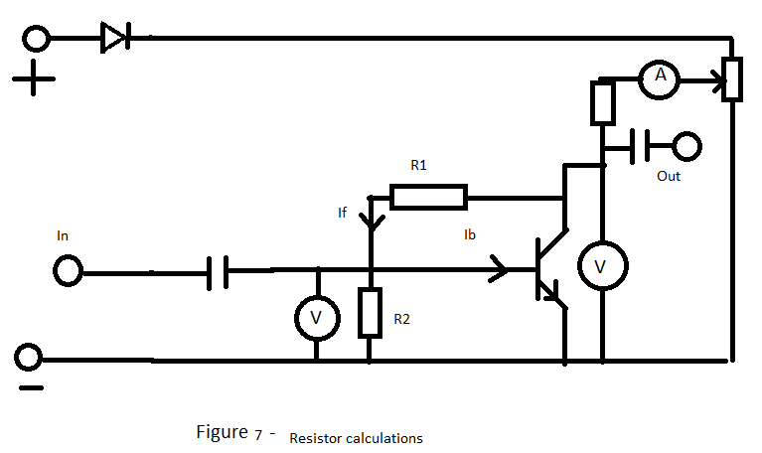
Output characteristic graph:
This quiescent point is chosen by how the user wants the transistor to be able to be used in this case we are creating an audio amplifier and so a signal goes positive and negative in almost equal proportions and so we want our voltage to be able to swing equally up and down the same amount so 7.5V is used as the supply is 15V. Next is the choice of current, we don’t want the current to be so high that the sound distorts or the transistor pops nor do we want it so small it can’t drive the load and so a value of 5mA is used as this gives a moderate output without destroying the transistors characteristics. In other systems this point would be needed to be chosen to give a specific peak output or have a specific gain while trying to reduce noise. This line gives us the output voltage $V_{ce}$dependent on the input $I_{c}$ . As of this the shallower the line the larger the gain is and the steeper the lower the gain. This can easily be seen by putting a sine wave into this and calculating at points the output gives .As the line is a negative gradient the higher the $I_{c}$the lower the $V_{ce}$meaning a 180 degree phase shift is generated from input to output signal. This all happens as the load line stands for the voltage over the resistor to the collector as when $I_{b}$is at its maximum the BJTs effective resistance is at its minimum meaning more voltage is over the resistor and when $I_{b}$is at its minimum the effective resistance is at its highest so less voltage over the resistor. The best resistance for this collector resistor can be calculated through the wanted load line by inverting the gradient in this case inverse of $\frac{dy}{dx}$ of $y=\frac{-(x-14.3)}{1360000}$ at any point is1.36kR.[7]
Transfer characteristic:
Using the equation made for transfer characteristic graph($y=4*{10}^{-11}*e^{0.0393x}$ where x is in mV and y in mA) we can find the value for $V_{be}$ at out quiescent current of 5mA which solves to give 650mV
Input characteristic:
As seen in figure 7 there is a resistor in parallel with the base emitter so we know the voltage drop over this resistor is the same as $V_{be}$, using the input characteristic equation ($y=4*{10}^{-11}*e^{0.0399x}$ where x is in mV and y in uA) we now know the value of $I_{b}$at this voltage is 7.34uA.
Resistors:
Looking at figure 7 we can tell that $V_{R1}=V_{ce}-V_{be}$ with a current $I_{f}$ we can calculate the resistance, using the rule of thumb $I_{f}={10I}_{b}$.Knowing the value of $I_{b}$ being 54.2 uA, $V_{be}$being 650mV and $V_{ce}$ 7.5V. Using basic Ohm’s Law $R_{1}=\frac{7.5-0.65}{10*7.34*{10}^{-6}}=93kR$.
For R2 we are again assuming $I_{f}={10I}_{b}$and we can also see that the current through it can be calculated by $I_{R1}=I_{f}-I_{B}$ $∴I_{R1}={9I}_{B}$ We also know the voltage is equal to $V_{be}$as it’s in parallel with it so equals 650mV. Using Ohms law $R_{2}= \frac{650*{10}^{-3}}{9*7.34*{10}^{-6}}=9.8kR$

Transconductance:
This transconductance ($g_{m}$) can be calculated by taking the gradient of the transfer characteristic at the operating point which can be found by taking the differential of the transfer characteristic equation at the quiescent base emitter voltage which comes out to be 0.195R^-1 which is exceptionally high for a transistor.
R base emitter:
$r_{be}$can be calculated by the inverse gradient of the input characteristic[6] at the operating point which again has been calculated by differentiating the equation for the input characteristic at the quiescent voltage which gives a value of 3450R.
Current gain:
By the equation $Beta=g_{m}*r_{be}$we get our value of beta (current gain) to be 672
Value Checking:
Transconductance:
This value is checked by using the equation $g_{m}\frac{q*i_{c}}{k*T}$which gives the value 0.193 which is very close to the value from the gradient which is 0.195,
R base emitter and current gain:
This is checked by using the equation $r_{be}=\frac{B*k*T}{e*i_{c}}$. Unfortunately this takes the value of beta which we calculated using $r_{be}$making this useless. Instead the value of current gain is checked in the data sheet at small signal current gain there is a variance between 450 and 900 and out beta value is almost dead centre of this leading me to believe that this is an accurate value for both $r_{be}$ and Current gain .
Gain:
To calculate the gain of a small signal (1Vpp) at the operating point the peak values are taken in this case 8V and 7V as the operating point is 7.5V, With these values of $V_{ce}$ the load line can be used to give the collector current at these voltages which are 4.63 mA and 5.37mA respectively. With the collector current using the transfer characteristic equation we can find the base emitter voltage, knowing these we have the change in base emitter voltage that gives a 1v collector emitter change and as gain is $\frac{V_{out}}{V_{in}}=\frac{∆V_{ce}}{∆V_{be}}$we have a value of 265 for the small signal gain.

Discussion

The resistors R1 and R2 that were put in the circuit (figure 7) were significantly lower than that calculated to have been needed for our specific transistor due to its high value of gain with the values needed being around 140% of what we used due to this results we gathered for the amplifier are out by a large amount as seen by the measurements taken when in DC operation:
Vbe(mV) | Ib(uA) | Ic(mA) | Vce(V)
647 | 11.24 | 8.56 | 7.4
Whereas what would be expected for a Vce of 7.4 is:
Vbe(mV) | Ib(uA) | Ic(mA) | Vce(V)
650 | 7.19 | 5.00 | 7.4

An AC 10kHz, 0.0154V wave is then added as shown in figure 7 where in is stated. The voltages $V_{in}and V_{out}$ when there is no load (out in figure 7) on the circuit were taken:
$V_{in}$(V) | $V_{out}$(V) | Gain
0.0154 | 2 | 129

Comparing the calculated gain when on dc (265) to that of the gain when supplied with an ac signal (129) we can see the fact the gain is almost perfectly half of what we expected which seems strange to me as when compared to the datasheet they quote that the gain goes up when in small signal region compared to dc, but they quote that they used 1kHz so this could be blamed on using such a high frequency signal or even on the extreme values of our transitor.
This time the same signal of 10kHz, 0.0154V is applied to the in but this time there is a load over the amplifier (out in figure 7) this load is a pair of earphones with a resistance of 32R:

$V_{in}$(V) | $V_{out}$(V) | Gain
0.0171 | 0.11 | 6.4

We can now see the gain has drastically decreased by a factor of 20 due to this load applied, as this load from the transistors view is in parallel with the load resistor which is of much higher resistance due to this the load resistor is almost negligible meaning a new load line must be created, we know the resistance of the load resistor is the inverse of the load line therefore the load line for the headphones ignoring the load resistor is 1/32 which may not sound steep but compared to 1/1360 is an extremely steep line. As discussed the load line is the line that gives us the change in voltage over the collector emitter ( out) given a collector current, as of this incredibly steep line the change in voltage is miniscule explaining the tiny gain as shown below:
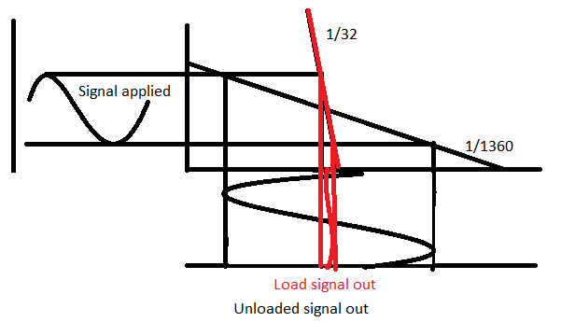
This also explains how this 180 degree phase shift is introduced as if you follow any point of the signal applied when it’s transformed by the load line the signal is reversed due to the negative gradient this occurs as the larger the voltage the higher the voltage drop over the resistor so less voltage is over the transistor giving a lower output but then the high turns into an equal low giving the transistor high output recreating the frequency input.
Even when the transistor is working with a load on small signal there is still a gain over the circuit of 6 times and therefore our circuit is acting as an amplifier and therefore successfully doing the job we intended. When testing the amplifier with louder music (no longer small signal) the music becomes distorted, this is because the load line is an approximation that stands for either dc or small signals that aren’t too high frequency, this is due to the transistors recovery time, this is the time needed for a transistor to change states when a change is made, when the signals are too high frequency the transistor doesn’t have enough time to go to the state it should be at before the applied signal is changed giving a distortion on the output, when the volume is too loud the changes are so large the transistors output can no longer be classed as linear as they follow the transfer characteristics curve (exponential but assumed to be linear at low frequencys).
The results that have been taken seem to follow very obvious trend lines with very little error and therefore I believe this was successful in gaining and understanding of gain in a transistor and why this all occurs. When comparing results to that of other people online and in the labs similar results are made with the graphs going exactly as expected. The values this specific transistor has given are a little distance from the average due to the suspected extreme transitor values as the manufacturer states this is a transitor that varies wildly due to the difficulty in creating constant values of transistor due to doping not being constant throughout batches.

Conclusion

The objective of this lab was to create a working amplifier using a BJT and as the gain when on ac with a load is above 1 I believe this was a success, some of the terms and reasons are still unclear but this has certainly improved my knowledge on the operation and steps when using a BJT in any circuit especially an amplifier. Equations were also created that give very accurate answers for the specific transistor that was used which are$y=4*{10}^{-11}*e^{0.0393x}$ , $y=4*{10}^{-11}*e^{0.0399x}$ for transfer and input characteristic respectively. There’s still a lot more to understand about the BJT to use this in a circuit freely but the characteristics have started to make sense.

References

[1]- NI Educational Laboratory Virtual Instrumentation Suite II Series(NI ELVIS II SERIES) USER MANUAL, National instruments (https://docs.google.com/a/sheffield.ac.uk/viewer?a=v&pid=sites&srcid=c2hlZmZpZWxkLmFjLnVrfGVsZWN0cmljYWwtY29udHJvbHMtbGFifGd4OjViZGIwYjJjYmYzNjQ1YWE)
[2]-Tenma Model 72-7770 Operating Manual, Tena test Equipment(http://www.mcmelectronics.com/content/ProductData/Manuals/72-7770.pdf)
[3]- AGILENT 34450A 5 ½ Digit Multimeter User’s Guide, Agilent technologies (https://vle.shef.ac.uk/bbcswebdav/pid-2399937-dt-content-rid-4568243_1/users/co1msj/E%26C%20Lab%20Equipment/DMM%20User%20Manual.pdf)
[4]- Keysight U8030 Series Triple-Output DC Power Supplies Data Sheet,Keysight Technologies(https://vle.shef.ac.uk/bbcswebdav/pid-2399938-dt-content-rid-4568305_1/users/co1msj/E%26C%20Lab%20Equipment/PSU%20data%20sheet.pdf)
[5]- Keysight Technologies InfiniiVision 2000 X-Series Oscilloscope Data Sheet, Keysight technologies(https://vle.shef.ac.uk/bbcswebdav/pid-2399939-dt-content-rid-4568154_1/users/co1msj/E%26C%20Lab%20Equipment/Data%20Sheet%20for%20Scope.pdf)
[6]-M H Miller, Introductory Electronics Notes University of Michigan-Dearbon 2000 (http://www-personal.engin.umd.umich.edu/~fmeral/ELECTRONICS%20I/0050%20IncParameter/0050%20IncParameter.pdf)
[7]-Ruye Wang, 2016-12-15, Dc operating point,( http://fourier.eng.hmc.edu/e84/lectures/ch4/node4.html)
[8]- Tom Duncan, John Murray, Success in electronics, (1983)

