Rgb LED
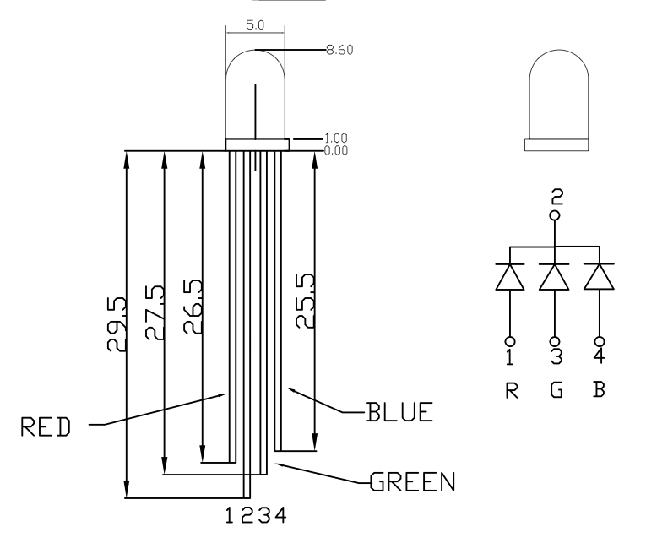
1.Hardware
You may remember that you can tell the cathode of an LED by its short leg and flat side unfortunately for an RGB led the common is donated by the long leg and usually there is a common cathode meaning the long leg means your negative connection.
Bearing this in mind connect your LED up on your breadboard using the diagram on the right to help you(you may want to colour code your wires), you could test them by attaching a voltage to see if they are the correct colour.
For now we will use the digital pins so connect pins 1,3 and 4 to separate pins and then use anywhere from 220 to 300 ohm resistor from pin 2 to ground (please don’t forget this you each have 1 RGB led and I don’t want them broken).

2.Software
By now you should be getting more used to the Arduino language and I will give you the outline of how your program should be written but you should now be able to derive the code from the cheat sheet and memory.
1.First we are going to program them all to be on so we should have a white light
First of all initialise your pins for input and output
Now set all pins to high
Check each pin is working (looks white, if its coloured only some pins are working )

2.Now when this is working we are going to make a rave light!
Your initialisation should now be done
Hard code each led on and off with delays so it ranges through every colour and mix of colour

3.If you’re feeling very brave and filled with programming power! (if not go onto 4)
You could try and make a loop to go through every colour on its own(have a look at “for loops”)

2.1.We’ve used the digital pins now so how about trying analogue pins(they are actually digital pins on your board, the ones with analogue(PWM to be accurate) have a ~ line next to them)
First try varying the light on 1 of the RGB led’s so it smoothly increases and decreases in intensity (use loops, if statements and analogue write).
2.2.Now use this idea on all 3 RGB leds at once so that it scrolls through colours (Think about this before starting to code, it can be rathe hard).

