Project title: Design an electrical supply infrastructure based on renewable energy sources

Day | Name of Team Leader (please enter)
Monday: First Day | Iakov Bobrov
Tuesday: Data Day | Yash Shah
Wednesday: Alumni Day  2nd person (if 6 in your team) | Kishan Patel  Yalman Omar
Thursday: Report Day | Hamish Sams
Friday: Presentation Day | James Godfrey

1) Understanding the problem (Mon)
Who are the stakeholders
What constraints does the context impose [what are the env, economic, social/community considerations and assumptions?]
Locals, government, students, NGO, council, investors, manufacturers, pressure groups - are the stakeholders in Bambui.
Political - a proposal could not get off the ground if the local chief, Fon, disagrees or does not support the idea. Also people may not want to change their lifestyle.
Environment - less pollution than current thermal plants, sustainable, reduced carbon emissions/greenhouse gases.
Social - the local people supporting the idea would pressurize the chief/government in going forward with plan. The people need a better, consistent source of power and any project should aim for longevity.
Technological - new technology is expensive, maintenance requires repairs and upkeep.
Legal - health and safety precautions should be considered, like insurances in case of emergencies (gas leaks and injuries). Permission from authorities and landowners will be needed.
Economical - lack of investment as large firms would look for profit. Government might want to tax or make it more expensive than electricity from conventional means. Reduce cost, farmers earn more money, waste reused as fertilizer. Good trade routes with nearby towns. Local market important for earning money.
2) The Design Question (Tues)
What exactly will your design achieve?
Quantify the problem. Identify and use data where available. Where no data,use your engineering judgement to seek approximations / assumptions with justification.
What exactly are you trying to achieve?
Bambui currently faces severe power cuts, happening multiple times every single day. Our main aim is to provide a stable supply of power to the town of Bambui; to design sustainable and long lasting infrastructure for a power plant which is efficient and affordable for the locals. Ideally this would be easy to to maintain, service and repair by university students or local engineers. A concept that utilises or improves Bambui’s existing infrastructure and geography would be also be desirable.

Who is it for?
Bambui currently has a population of approximately 17,000 [2][12] and is situated in a very rural area. The majority of residents are farmers (90% of the economy is agriculture based [19]). A university has been recently set up to attract students but can’t be consistently operational due to power outages affecting computers. This also goes for the hospitals in Bambui which rely on stable power to run equipment.
A stable source of power will allow the town to develop economically attracting investors as Bambui is a major trading route in cameroon, the university will attract more students and in general lead to population growth within the area, healthcare will improve, several jobs will also be created.
Currently Bambui consumes 4760 KWh of electricity per day[e]

Resources available
Bambui naturally has good wind currents through it and has a stream and foundations for a hydroelectric dam nearby. The people do not have any waste systems in place currently other than a landfill. The lack of fridges mean storage is an issue and thus a great amount of food is wasted. Also farm animals produce large amounts of waste, typically used as fertiliser. Bambui experiences long rainy periods affecting any solar powered equipment. Nuclear power is something that is not available or advisable in an LEDC like Cameroon.
3) Design Criteria based on Specific Measurable Achievable Realistic Timely (Tues)
Specific- Brings reliable power to the people of Bambui via renewable sources.
Measurable- Need at least 4760 KWh generated to supply the town
Attainable- Meet the required power needs currently and have the infrastructure to increase capacity.
Reliability- The new power supply will be have to be stable, work consistently all year round and not experience regular power cuts
Timely- There is no needed rush to get a plant as there is an on off supply currently but the sooner the better due to the needs of facilities such as hospitals.
4) Design Concepts (Tues/Wed)
5 or 6 different designs (1 for each team member) each with accompanying annotation(s).
Initial design concepts include the four major renewable resources, a brief description of how they work is given but they are very technical systems:
- Wind
Wind turns a turbine generating electricity. This would be a viable option as Bambui has good wind currents and is surrounded by several hills, wind turbines placed on top of hills would be very efficient. In another study an analysis carried out on corn and soybean crops in the central areas of the United States noted that the microclimate generated by wind turbines improves crop growth as it prevents the late spring and early autumn frosts, and also reduces the action of pathogenic fungi that grow on the leaves. Even at the height of summer heat, the lowering of 2.5–3 degrees above the crops due to turbulence caused by the blades, can make a difference for the cultivation of corn. (Takle, Gene and Lundquist, Julie. 2010)

- Solar
Uses sunlight to generate electricity. Solar power could be applicable, however it depends on a constant supply of sunshine. Long rainy periods due to Cameroon’s climate would affect its ability to function creating an issue with supply and demand. The solar panels could be positioned on surrounding hills where they are more likely to receive sunlight. Panel will need to be cleaned regularly and a lot will be needed to generate enough power.

- Biogas
Works by converting waste into gas and thus fuel. Biogas is a cheaper alternative as the town does produce a significant amount of waste and is considered carbon neutral. May also propose a sewage collection system and improve the town’s sanitation. Could be positioned near existing landfill.

- Hydroelectric
Stream powers turbines and thus electricity is generated. Bambui did have a hydropower station in the past but was shut down due to lack of funds, the foundations of this plant still exist. The climate of the area allows for rain 8 months of the year and hence this would be a reliable option.

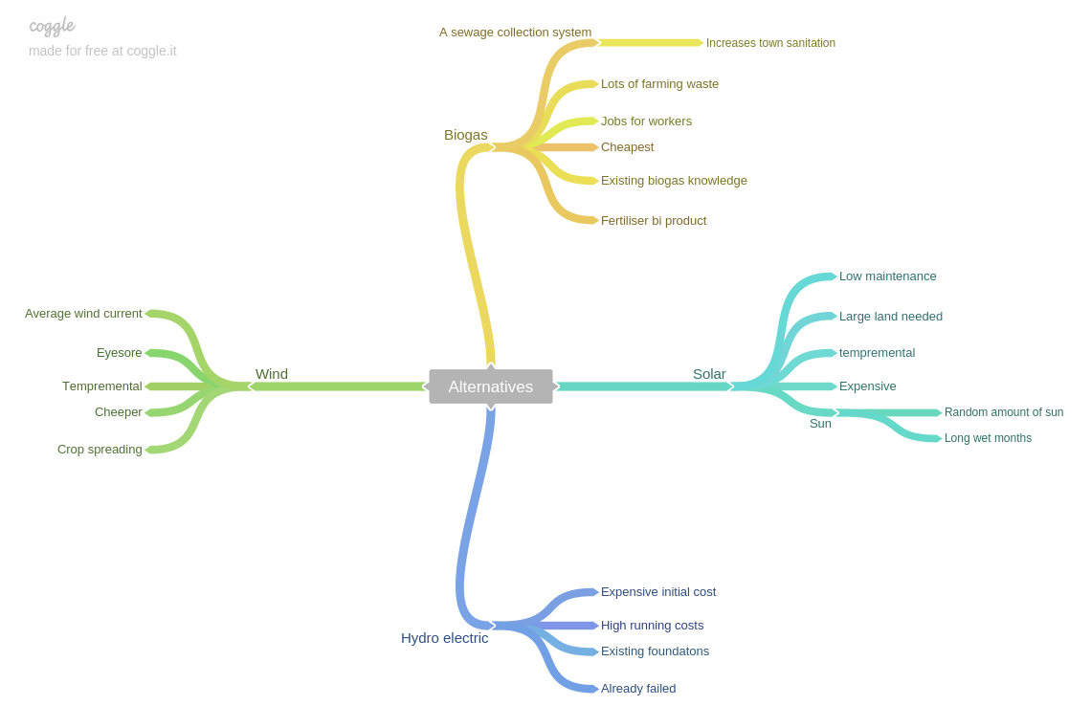

5) Option evaluation (Decision matrix) (Wed)
Option evaluation and justification of decision using decision matrix with sensitivity analysis (and reasons for selecting and rejecting).
According to our decision matrix, from which the environmental effect and meeting demand were weighted the most important and set up weighted the least, we concluded that a biogas power plant would be the most efficient source of producing electricity.
A biogas system would effectively meet consumer demand as Bambui currently requires 200 KW, and a typical biogas plant(300m^3) is capable of producing 220KW. With Bambui being a Major farming economy, and with major preservation issues, significant amounts of food waste is produced which forms the basis of the the waste used in the digesters for the plant. The plant will recycle waste and reduce land required for landfills, the by-products from the plant are organic and can be converted to fertilizers which will inturn be sold back to the farmers at a lower cost hence benefiting everyone.

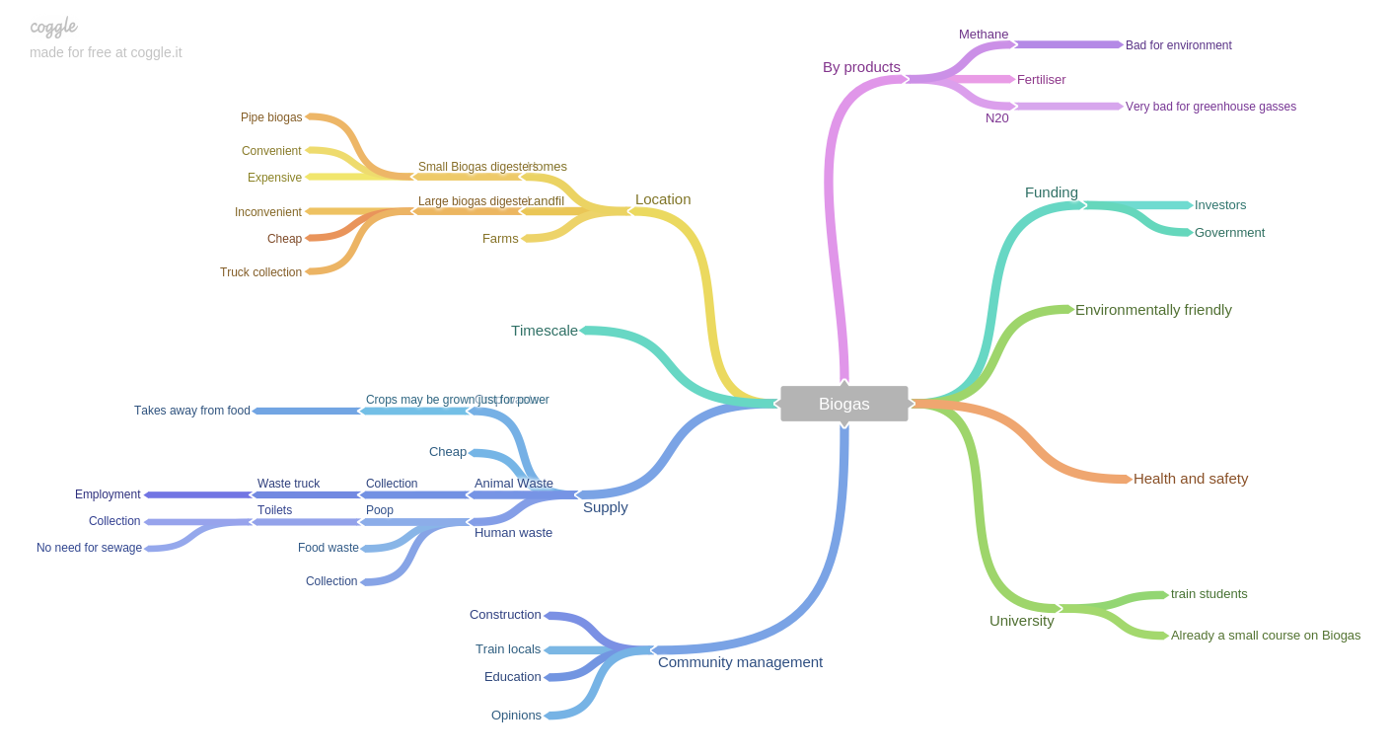
The other solutions each have their own disadvantages with hydroelectric being too expensive even with pre built foundations, solar takes up too much land and is too unreliable to base a town’s only power off, the same for wind especially with the long periods of extreme weather and the fact there is a hospital and university.

6) Developed Design (Thu)
- Show how the design fulfills the needs of the users/stakeholders with engineering calculations to justify and quantify the solution.
Feasibility study

Technology
Currently biogas systems are available in the town and there are limited transport systems in place. There are existing trainees that understand and are already working on biogas systems at a nearby university. Additionally Cameroon already has a national grid, so Bambui could use its existing overhead power lines and substations that are connected to the grid to connect the biogas plant into it. The town can then sell any excess back to the grid via the grid connection.
Economy
It will cost £1.1Million[n] to implement, this shouldn’t effect the council much as it should be almost entirely investor paid. Hopefully the system should be self sustaining after the initial starting cost with excess money for payback which will take 10 years with around £100,000 spare for any unexpected costs.
Legal
There are not many laws around the area in Bambui regarding power and therefore it seems to be more of a case of if the council agrees and wants the biogas system there it will be in place. The Government are likely to back any renewable energy solution as well.

Operations
The system, if it follows the calculations and numbers given, should create enough power to supply the entire village with some spare that can be sold or charged into batteries for later use. It also increases the sanitation of the village and should lower the spread of disease. Increasing quality of life and allowing products to be stored in fridges or freezers so that they can be sold throughout the year and less waste is made. The biogas will also be able to cope with any fluctuation in demand but it will operate consistently all year round. Furthermore if there is a shortage the existing national grid could be used to provide any additional power.
Schedule
It will take around a year to implement the system into the town, the waste will still exist and there will only be 1 year of the current situation when implementation starts.
Conclusion
All sections of the biogas system can be delivered to the area of Bambui using the roads and therefore is it feasible. The existing power lines can cope with the system, currently the unreliable source and demand issues affect its consistency. There is already a few trained personnel for the biogas plant and therefore the university can train more and get these people better jobs . With the funding to initially get the project off the ground the system should be self sustaining and therefore be viable with investors getting their money back in 10 years. There shouldn’t be any legal issues. The systems should be able sustain the entire village with spare power, this should eliminate most if not all power outages, the system will also increase the lands sanitation and allow the farmers to create more money from their produce. The time to implement isn’t too long.
Benefits for Stakeholders
The townspeople will gain an improved quality of life with appliances able to run and amenities like hospitals able to function more effectively. The healthcare of the locals will therefore also improve. The market would also have the opportunity to grow and the local economy will be boosted. Jobs in construction and maintenance will also be generated. The local students will also have the opportunity to learn about biogas and improve their knowledge, as well as computers being able to run at the university.

NGOs such as charities and environmental pressure groups are likely to support the plant because it improves the Bambui’s quality of life and is also a renewable, sustainable power source. The Government in Cameroon are currently concerned about the lack of electricity as just 17% of rural areas have electricity so are likely to publicly back the project. This could be through subsidise & giving grants or giving tax breaks. Cameroon is currently pushing for hydroelectric power so they are only interest in sustainable solutions such as the one put forward here.

Investors have a real opportunity to create a platform for future investors of the area and can get the locals on side for future development plans. Bambui is also a hub for trade at the market so it is an optimum development opportunity. Additionally they can make their money back from locals with a decent payback time. The current population growth is 5%, if this level stays approximately the same it will increase to around 28,000 in 10 years meaning there will be more future customers and the opportunity to grow the plant size. Educating the local students will generate well trained engineers who can work in other upcoming projects. There is also a humanitarian benefit as the locals quality of life will improve with less waste and constant electricity.

Risks for Stakeholders
The locals would experience some disruption during construction and may have to deal with any potential smells. Investors and the government may have issues with acceptance from the locals. They would have to be thoroughly consulted before construction because they have the potential to stop the project. A key figure will be the area Fon who is effectively a tribal chief of chiefs and makes many key decisions. Public forums would limit any objection and likely get locals on side. This is unlikely as the development would improve their quality of life. The plant also deals with flammable gases but any technical issues can be managed effectively through health and safety procedures. This makes biogas as safe as any other solution.

Terrorist group Boko Haram are currently at war with the government so could potentially disrupt any construction and day to day running. There is a very low chance of this happening but security would be high throughout construction anyway. Moreover, corruption levels are very high in Cameroon, which can be a major problem if we allow the government to get too involved. Additionally, in Cameroon taxes are high, also the level of investment and trade are low currently. If the plant fails there would be very less chance of investment in the future as the hydroelectric dam has failed to be completed.

Due to the rise in the cost of petroleum in Cameroon it would cost more and more to build the plant every year. However, gasoline is still cheaper there than in the UK: 1.03$ compared to 1.50$ per liter of gasoline (Globalpetrolprices.com, 2017).

According to both paved and unpaved road networks in Cameroon are in bad conditions (Countryreports.org, 2017). Also, it is not safe to drive on the roads of Cameroon because drivers ignore safety rules and there are few traffic signs on the roads. This could influence significantly the logistics of building a plant in Bambui and affect timescale.

Data
Electricity consumption per capita in Cameroon(2011) = 255KWh per year [1]
Population of bambui (2012) = 17k [2][12]
Rate of population growth = 4.8% [4]
5 people per household[5]
Each person produces 0.125kg of faeces per day, and 0.7 kg of solid waste per day [6]
Feces produces about 25m^3 biogas per tonne [7]
food waste produces 110 m^3 biogas per tonne[8]
Assuming farming waste is equal to food waste
6KWh calorific energy per m^3 of biogas[9]
70KWh per 50 households per day currently [10]
33% efficiency [11]
650,000T of farm waste per year in cameroon [17]
Area of cameroon = 472,710m^2[14]
Area of bambui calculated = 288m^2
4,750 cows in Bambui [18]
30kg per day of cow manure from each cow[15]
Cost of a biogas plant[16]
Crop waste biogas percentages[17]
Assume 0.6 of the manure is given to us

Calculations
(255000/365)*17,000 = 12MWh a day to be a normal town = 500KW system to support[a]
17,000/5 = 3,400 households[b]
3,400/50 = 68 lots[c]
68*70=4760KWh per day[d]
4760KWh per day[e]
4760/24 = 200KW[f]
200KW to support current consumption[g]

(17000/(5*5))=680 Digesters needed[h]

0.125*17,000 = 2125 Kg = 2T
2*25 = 50 m^3
6*50 = 300 KWh per day = 12.5KW from feces[i]

0.7*17,000 = 12,000Kg = 12T
12*110 = 1320 m^3
6*1320 = 7920 KWh per day = 330KW from food
20% efficiency means 70KW [j]

650,000*288/472,710=400T per year
400/365 = 1T per day
1*110*6/24=30 KW[k]

4750*30=142,500 Kg per day=142T
142*25*6/24=887 KW
887*0.6*0.2=106KW[l]
Total of 220KW including inconsistencies on the power generation and ability to get all substance to the plant.[m]

Cost = 4000*220= £880,000 with added things like truck and training and transport costs around
£1.1 million[n]

1100000/(3650*3400)=£0.09 per household per day for payback in 10 years time[o]
- Show how the design addresses the environmental, economic and social/community considerations and assumptions.
The environmental impact of such a system is that it removes waste material that would be a potential source of pollution and converts it into usable energy. While combustion of biogas, like natural gas, produces carbon dioxide (CO₂), a greenhouse gas, the carbon in biogas comes from plant matter that fixed this carbon from atmospheric CO2. Thus biogas production is carbon-neutral and does not add to greenhouse gas emissions. Further, any consumption of fossil fuels replaced by biogas will lower CO2 emissions, hence having a positive environmental impact (Wilkie, 2015).
Biogas technology shall help improve environmental quality through the elimination of agricultural wastes that would otherwise accumulate and become a major source of pollution and possible contamination.

The plant shall be designed to run by locals, creating various employment opportunities; during the initial construction of the plant, running the plant, collection of waste, manufacturing the fertilizers, individual substations e.t.c.
Food processing companies will be attracted to the town opening up the market and increasing income generation, enhancing economic development.

The main aim of the plant would be lifestyle improvement. As a result of this, power cuts in the region would drastically reduce and therefore lead to hospitals operating more effectively providing better healthcare for the people. Households in Bambui lack refrigerators, a constant supply of power will help enable people to acquire these. Farmers will be able to preserve their crops leading to better sales, and therefore the plant will be fit for the purpose.
- Detail the Implementation Plan in terms of installation, operation, future maintenance by users and any associated risks.
Funding in the renewable energy sector is increasing by the year; 5% between 2014 and 2015. In addition, there has been a 58% increase in funding in the Middle East and Africa. This means a global investment of $285.9bn in renewable energy, with $12.5bn in the Middle East and Africa. (FS-UNEP Collaborating Centre for Climate & Sustainable Energy Finance, Global Trends in Renewable Energy Investment, 2016). Cameroon has a 17% rural access to electricity and the government is attempting to increase this by reducing subsidies for kerosene and gas and focusing on renewable resources. (USAID, Cameroon Power Africa Fact Sheet, 2016). These statistics are promising for the project in Bambui as it shows a possibility of funding from both the government and external investors. The construction of the plant is likely to take up to a year. The materials used for the construction can be purchased locally from neighbouring towns/cities which will be beneficial for the area. Installation of the plant shall be near landfill sites; Bambui has 2 landfills currently, the plant will recycle waste and reduce land required for landfills. This will enable any waste to be directly added to the digester and eventually save on transportation costs. The plant will only operate on organic waste which will be obtained from households and farms. Household and other human waste will be collected on a weekly basis by local dump trucks, farm waste will be delivered to the plant by farmers themselves. After collection the waste will undergo decomposition and the gas will be produced.

Biogas primarily consists of methane which is purified into bio-methane. The by products which include the waste bio-slurry shall be converted into organic fertilizers and be sold back to the farmers at a relatively low price. Nutrients, like nitrogen and phosphorous are conserved in biogas effluents and can be used for the manufacture of fertilizers, this can also be used as an incentive in which they bring in farm waste to the plant and in turn take the fertilizers for free. The biogas will be used to boil water to run steam turbines producing electricity. The electrical energy produced will be fed to the the national grid for consumption. Any surplus energy exported to the grid can earn the plant additional income.

Maintenance shall be conducted on a regular basis, to ensure to the plant is running smoothly, maintenance of agitation and pumping/flushing equipment will require manual operation. (Marches Biogas. Anaerobic Digestion Engineering, 2017).
The image represents a process of anaerobic digestion (Marches Biogas, 2016).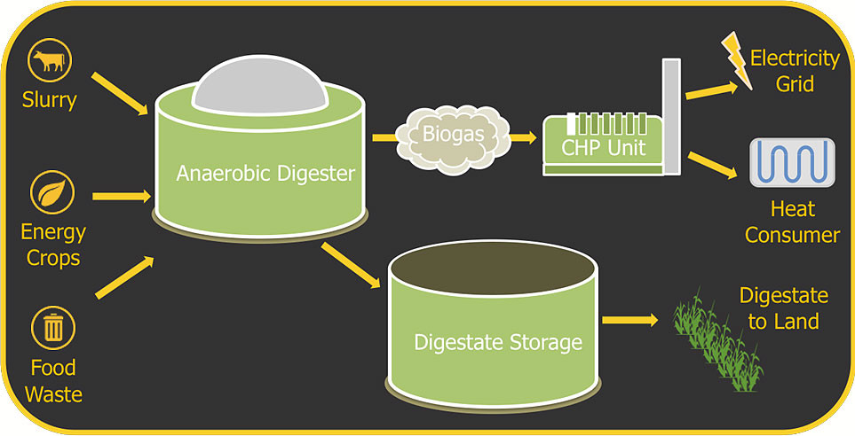
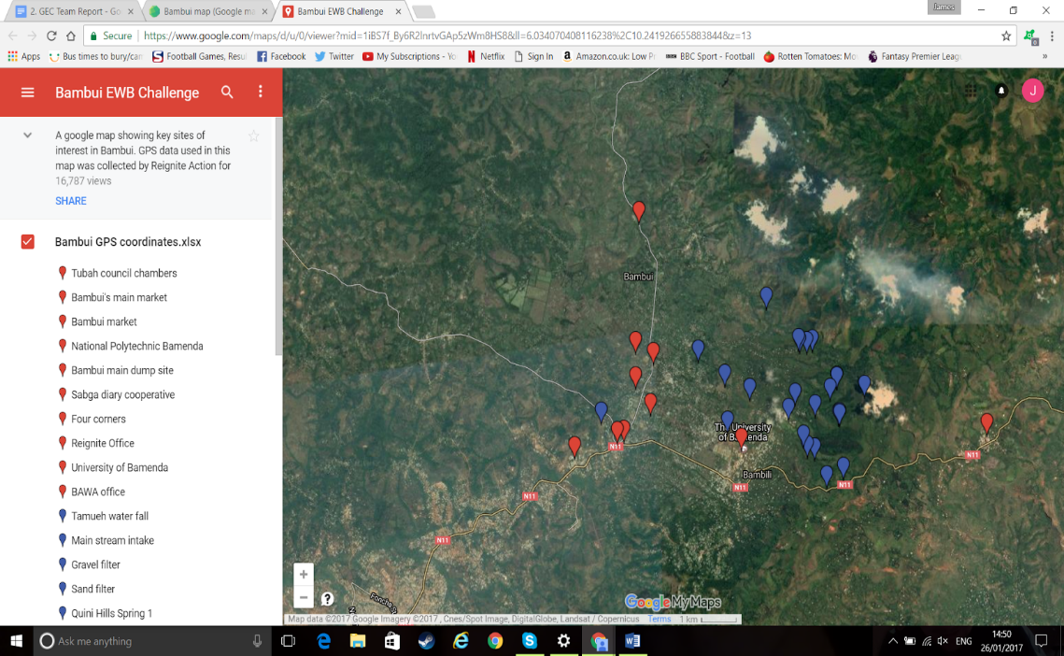
Map of Bambui. The Red box is an indicator of the region where an initial plant would be located. The marker inside the box is the location of Bambui’s main dump site (EWB Resources, 2014).

Hazards.
In the following table the hazards of launching the plant are listed. Each hazard was assessed by taking account of the risks and dangers (1 - low, 10 - high). Finally, the recommended precautions to minimize the hazards will be implemented.

Hazard | Risk | Danger | Precautions
Gas leaks | 1 | 8 | Addition of hydrogen sulfide for smell. Detection diaphragm replacement. Equipment has to be checked regularly.
Fumes | 4 | 2 | Personal protection equipment for workers. A forced ventilation system must be permanently installed in order to counteract the risk of asphyxiation and poisoning in the event of an escape of gas.
Flames | 4 | 6 | No smoking is allowed inside of the plant. Electric lights with signs “NO SMOKING” have to be set.
Unauthorised visitors | 1 | 7 | Security.
Spreading of  diseases | 7 | 2 | Workers have to use gloves and shovels when collecting the material. Regular cleaning of the facilities and tanks has to be done.
Negative pressure | 5 | 8 | The oxygen in the air will kill the biogas bacteria and the gas production rate will drop. Installation of pressure gauges with regular checks. Always maintain a positive pressure in the system.

- Show your proposals for user/stakeholder consultation (necessary throughout the design development process).
Throughout the process all stakeholders will be liaised with to ensure all parties are happy with the design. Investors are likely to want to push through the project quickly so they can begin making a return on their capital, this is to be expected but the locals can not be forgotten about because it will be them paying for the electricity and employed to maintain and manage the new resource. Public forums featuring the Fon would allow the design to be viewed and commented on by the residents. The government will want regular updates on progress and these should be met. Any additional support offered would be helpful, but corruption concerns should not be forgotten about.

NGOs are likely to support the project so reaching out for volunteers and small investments to help get the project off the ground would be useful. Engaging the university students to assist would also be beneficial to both them and the biogas generators construction. Investors will want to the project completed on time so this key to keeping them onside. Previous plans, such as the failed hydroelectric project, have folded due to the lack of funding. The loss of funding will kill the project so the any question or concerns from the investor will have to be satisfied.
7) Writing and references (Thu)
References:

[1] - http://data.worldbank.org/indicator/EG.USE.ELEC.KH.PC
[2] – Tubah Council report
[4] - http://www.ewbchallenge.org/reignite-action-development/forum/expected-population-growth
[5] - http://www.ewbchallenge.org/reignite-action-development/forum/no-households-bambui
[6]- Okot-Okomu, J, 2012, “Solid waste management in African cities- East Africa”, Intech
[7]-Anaerobic digestion, Biogas yields table, retrieved 10/5/2015 from
http://www.biogas-info.co.uk/biogas-yields-agri.html
[8]-seai, “Gas yields table”, seai, retrieved 11/5/2015 from http://www.seai.ie/Renewables/Bioenergy
[9]-Electrigaz 2015, Biogas FAQ, retrieved 11/5/2015 from http://www.electrigaz.com/faq_en.htm
[10]-http://www.ajol.info/index.php/bjt/article/view/15393
[11]-http://www.electrigaz.com/faq_en.htm
[12]-https://ewb.box.com/shared/static/xj5qdsqyrsx5v629ze04fif2vk49itxx.pdf
[14]-https://en.wikipedia.org/wiki/Geography_of_Cameroon
[15]-https://fergusonfoundation.org/lessons/cow_in_out/cowmoreinfo.shtml
[16]-http://www.electrigaz.com/faq_en.htm
[17]-http://www.fao.org/docrep/003/x6553e/X6553E04.htm
[17]-http://www.ewbchallenge.org/overview-farming-practices-bambui
[18]-https://ewb.box.com/shared/static/xj5qdsqyrsx5v629ze04fif2vk49itxx.pdf
[19]-http://reignite.org.uk/why-is-irrigation-fundamental-to-the-inhabitants-of-bambui-cameroon/

Countryreports.org. (2017). Cameroon Traffic Safety while traveling. - CountryReports. [online] Available at: http://www.countryreports.org/travel/Cameroon/traffic.htm [Accessed 26 Jan. 2017].

Globalpetrolprices.com. (2017). Gasoline prices around the world, 23-Jan-2017 | GlobalPetrolPrices.com. [online] Available at:
http://www.globalpetrolprices.com/gasoline_prices/ [Accessed 26 Jan. 2017].

FS-UNEP Collaborating Centre for Climate & Sustainable Energy Finance. Global Trends in Renewable Energy Investment, 2016. [online] Available at: http://fs-unep-centre.org/sites/default/files/publications/globaltrendsinrenewableenergyinvestment2016lowres_0.pdf [Accessed 26 January 2017]

Marches Biogas. Anaerobic digestion engineering. (2017). AD Explained. [online] Available at: http://www.marchesbiogas.com/ad_explained [Accessed 26 Jan. 2017].

Marches Biogas, (2016), AD Explained [online]. Available at: http://www.marchesbiogas.co.uk/images/adexplained.jpg [Accessed 26 January 2017].

Takle, Gene and Lundquist, Julie. Wind turbines on farmland may benefit crops Ames Laboratory, 16 December 2010. Retrieved 10 March 2011.

USAID. Cameroon Power Africa Fact Sheet, 2016. [online] Available at: https://www.usaid.gov/powerafrica/cameroon [Accessed 26 January 2017]

Wilkie. (2015). Wilkie, Dr. Ann C. "Biogas - Frequently Asked Questions (Biogas FAQ)". Biogas.ifas.ufl.edu. N.p., 2015. Web. 26 Jan. 2017.

