Hamish Sams EEE160 Passive networks lab report finished 06/11/2016
Collaborator: Chun Lo
Introduction
In this lab, we are looking into how inductor and capacitor reactances interact within a circuit depending on frequency .Previously a small amount of testing on this has been carried out and looked into but in little depth and only in first-order resonant circuits. The objective of this is to learn of how second and first-order resonant circuits act depending on the frequency and value of the components in the circuit, this will then be compared to a mathematical version to see how close these are to real life values.
Theory
Measurements taken:
Frequency (Hertz) - f(Hz) - This is the frequency of sine wave supplied to the circuit.$V_{i}$
Voltage in (Volts) - $V_{i}$ (V) - This is the peak to peak voltage over the circuit.
Voltage out/over resistor (Volts) - $V_{o,r}$ (V) - This is the peak to peak voltage over the resistor.
Voltage over inductor (Volts) - $V_{l}$ (V) - This is the peak to peak voltage over the inductor.
Voltage over capacitor (Volts) - $V_{c}$ (V) - This is the peak to peak voltage over the capacitor.
Equations:
Gain(VV-1 / d.i. / )= $\frac{V_{o}}{V_{i}}$
Gain(Db) =20Ln(Gain)or 20Ln($\frac{V_{o}}{V_{i}}$)
Corner frequency for inductor (Hz): $2πf_{c}=ω_{c}=\frac{R}{L}$
Time constant for a inductor(S): $τ=\frac{L}{R}$,$τ=\frac{t_{Rise,Fall}}{2.2}$
Corner frequency for capacitor(Hz): $2πf_{c}=ω_{c}=\frac{1}{RC}$
Time constant for a capacitor(S):$τ=CR$,$τ=\frac{t_{Rise,Fall}}{2.2}$
Corner frequency ($f_{c}$) is only in first-order resonant circuits. It is the point at which the resistor and inductor or capacitor are dissipating equal amounts of energy.[1]
Time constant ($τ$) is the length of time the capacitor or inductor needs to charge or discharge to $\frac{1}{e}$ of its final value
Second order circuits
Resonant frequency (Hz): $f_{o}=\frac{1}{2π\sqrt{LC}}$
In a second order circuit there is a frequency where the two reactances are equal and opposite and cancel out to leave the circuit completely resistive. This is called the resonant frequency($f_{o}$)The quality factor (Magnification factor[1]) This defines the sharpness of the curve, this means if there was a cutoff at -3db fewer frequencies would be accepted surrounding the resonant point

Q-Factor(quality factor) ($ff^{-1}$//d.i.// ):
$$Q= \frac{1}{R}\sqrt{\frac{L}{C}}$$
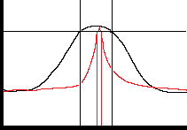
$Q= \frac{f}{∆f}$

Gain(Db)

Frequency(Hz)(Log scale)
Red- Small change in frequency means large quality factor
Black - Large change in frequency small quality factor
The quality factor can also be measured by taking the change in frequencies $∆f$between the two points where the graph is equal to -3db.
Parallel second order circuits:
Q-Factor(quality factor) ($ff^{-1}$//d.i.// ):
$$Q=R\sqrt{\frac{C}{L}}$$
Method
The experiment was carried out using a Agilent Technologies Trueform Series Waveform Generator[2] to create the signals and a Keysight Technologies infiniivision 2000 X-Series Oscilloscope[3] which is a non-isolated digital storage oscilloscope.
1st order circuits
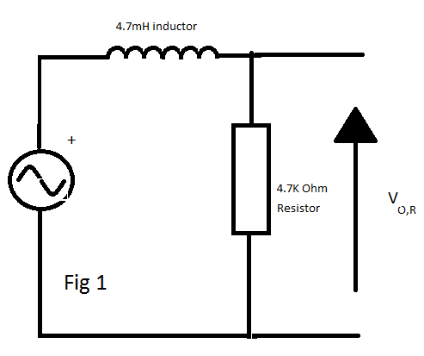
First of all create the circuit in figure 1 for the LR and figure 2 for CR, using the signal generator to create a sinewave signal of $1 V_{Pk}$($2V_{PP}$) varying the frequency from 1kHz to 500kHz. Take results at a constant separation. Find the point when the Gain in db I around -3 and take more results around that point. After this set the signal generator to create a sinewave signal of $5 V_{Pk}$($10V_{PP}$) and calculate the rise and fall time from 10% to 90%.
Do CR circuit and method for 2nd order
Results
LR unknown inductor 4.7k resistor
F(Hz) | Vi(V) | Vo(V) | Gain(Db)
1,000 | 2.03 | 2 | -0.129
2,000 | 2.04 | 2.03 | -0.043
5,000 | 2.04 | 2.03 | -0.043
10,000 | 2.04 | 2.03 | -0.043
20,000 | 2.04 | 2.02 | -0.086
50,000 | 2.05 | 1.96 | -0.39
100,000 | 2.06 | 1.77 | -1.318
200,000 | 2.07 | 1.29 | -4.108
500,000 | 2.07 | 0.4 | -14.278
120,000 | 2.06 | 1.69 | -1.72
140,000 | 2.07 | 1.57 | -2.401
160,000 | 2.07 | 1.49 | -2.856
180,000 | 2.07 | 1.4 | -3.397

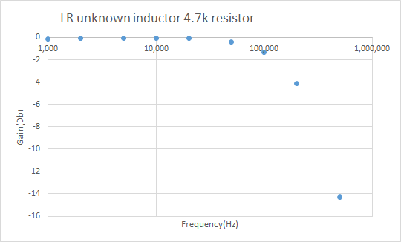
After taking the data and looking at the results to try and find where the graph crosses at -3db you are dead in the centre of two points and so instead of guessing these points with a curve more points were taken to clarify the position at which it crosses.
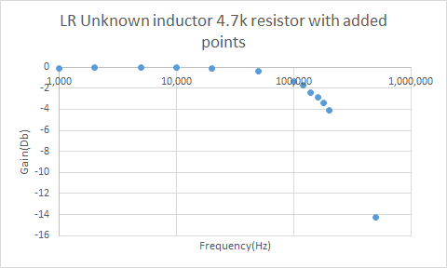
More data was taken around this region to see clearer how the system works and get a more accurate value for the frequency corner.
By graphical methods, the corner frequency was found to be 160KHz in the system.
By calculation$2πf_{c}=ω_{c}=\frac{R}{L}$, $f_{c}=\frac{R}{2πL}$, $\frac{4,700}{2π×0.0047}$=159KHz
(The value of 4.7mFH was read off the device after for checking)
Taking our measured value of 160KHz we can work out the value of Inductance by using the equation:$2πf_{c}=ω_{c}=\frac{R}{L}$L, To give us $L=\frac{R}{2πf_{c}}$ , $\frac{4,700}{2π×160,000}$ =4.68mH
Which is very close to the value stated by the manufacturer of 4.7mH. With only ()$\left|\frac{4.68-4.7}{4.7}\right|×100=$0.43% uncertainty.
Another measurement was taken from the circuit, this was the rise and fall time(The time it takes for the wave to go from 10% to 90% of its peak value)
Rise time = 1.9 µs
Fall time = 1.9 µs
From this, we can work out the time constant ($τ$) from the equation $τ=\frac{t_{Rise,Fall}}{2.2}$
Giving us $\frac{1.9×{10}^{-6}}{2.2}=8.64×{10}^{-7}s$
By calculation $=\frac{L}{R}$ , $τ=\frac{0.0047}{4700}=1.0×{10}^{-6}$
Again by working out the uncertainty ($\left|\frac{8.64-10}{10}\right|×100=$)13.6% is not far off the value. The issue with this is the resolution of the oscilloscope as to get the rise or fall time the oscilloscope must first recognise the correct peak to peak voltage to know what is its maximum and then also correctly recognise the 10% and 90% marks inducing 3 possible margins of error in one single piece of equipment, not to mention the small ($×{10}^{-6}$) values created compared to volts and millivolts for gain equations needing more accuracy from the device which it evidently can’t supply.
Using both equations $τ=\frac{L}{R}$ and , $f_{c}=\frac{R}{2πL}$we can derive$f_{c}$ =12
using this to create a value for the inductor using solely $τ$
$\frac{1}{2π×8.64×{10}^{-7}}$=184KHz, $L=\frac{R}{2πf_{c}}$ $\frac{4700}{2π×184,000}$=4.07$×{10}^{-3}$H
as expected the answer calculated using is much farther from the manufacturers due to the larger source of error.
CR 2.2nf capacitor 4.7k resistor

F(Hz) | Vi(V) | Vo(V) | Gain(Db)
1,000 | 2.05 | 0.18 | -21.13
2,000 | 2.05 | 0.31 | -16.408
5,000 | 2.05 | 0.66 | -9.844
10,000 | 2.05 | 1.14 | -5.097
20,000 | 2.05 | 1.62 | -2.045
50,000 | 2.05 | 1.95 | -0.434
100,000 | 2.05 | 2.03 | -0.085
200,000 | 2.05 | 2.05 | 0
500,000 | 2.05 | 2.05 | 0
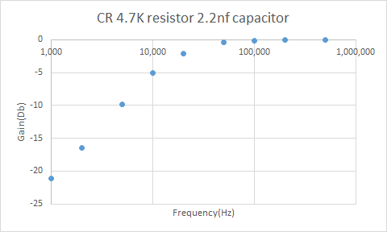
In this CR circuit we are fairly close to a point at -3Db and therefore I found it unnecessary to take more points around this region.
Graphically finding $f_{c}$by finding the crossing at -3Db gives the value of 14KHz
By calculation $2πf_{c}=ω_{c}=\frac{1}{RC}$, $f_{c}$= $\frac{1}{2πRC}$, $f_{c}$= $\frac{1}{2π×4700×22×{10}^{-9}}$= 15.3KHz
Then using the found value to get the capacitance to compare to actual using the equation $2πf_{c}=ω_{c}=\frac{1}{RC}$, $C=\frac{1}{2πf_{c}}$, $C=\frac{1}{2π×14,000×4700}$ =2.42nF
This is fairly close to the actual of 2.2nF but if possible more measurements should’ve been taken for a more accurate result. The calculated compared to the manufacturers is only ($\left|\frac{2.42-2.2}{2.2}\right|×100=$)10% out which is much more likely to be down to less accurate data than a capacitor tolerance.
The measured rise and fall time of the circuit was:
Rise time = 29.0µs
Fall time = 29.0µs
Using the equation,$τ=\frac{t_{Rise,Fall}}{2.2}$ the time constant is $\frac{29×{10}^{-6}}{2.2}=1.32×{10}^{-5}$s
and by manufacturers value the time constant is $τ=CR$ $2.2×{10}^{-6}×4700=1.03 ×{10}^{-2}$ ERROR HERE FIX IT AND COMMENT ON IT AND WORK OUT THE VALUE OF THE CAPACITOR FROM IT AND GAIN COMMENT.
LRC 100/1200 ohm resistor, 4.7mH inductor, 0.01µF capacitor

LRC 100 Ohm
F(Hz) | Vi (V) | Vo(V) | Gain(Db)
1,000 | 2.86 | 0.017 | -44.518
2,000 | 2.86 | 0.035 | -38.246
5,000 | 2.86 | 0.092 | -29.852
10,000 | 2.84 | 0.213 | -22.499
20,000 | 2.85 | 1.051 | -8.665
50,000 | 2.85 | 0.237 | -21.602
30,000 | 2.85 | 0.684 | -12.396
15,000 | 2.86 | 0.43 | -16.458
23,000 | 2.85 | 1.54 | -5.346
17,500 | 2.86 | 0.652 | -12.842
26,000 | 2.86 | 1.13 | -8.066
LRC 1200 Ohm
F(Hz) | Vi(V) | Vo(V) | Gain(Db)
1,000 | 2.93 | 0.21 | -22.893
2,000 | 2.93 | 0.405 | -17.188
5,000 | 2.91 | 0.98 | -9.453
10,000 | 2.91 | 1.81 | -4.124
20,000 | 2.91 | 2.65 | -0.813
50,000 | 2.91 | 2.06 | -3.001
22,000 | 2.91 | 2.7 | -0.651
26,000 | 2.91 | 2.69 | -0.683
28,000 | 2.91 | 2.68 | -0.715
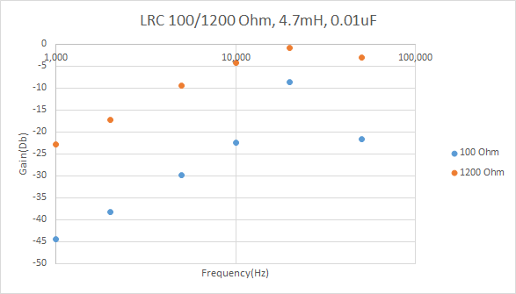
This initial graph shows an increase up to a point and then a decrease but by the lack of points it seems like a linear graph. To look into how the graph actually acts at these higher gains more points must be taken to point out these definitions.
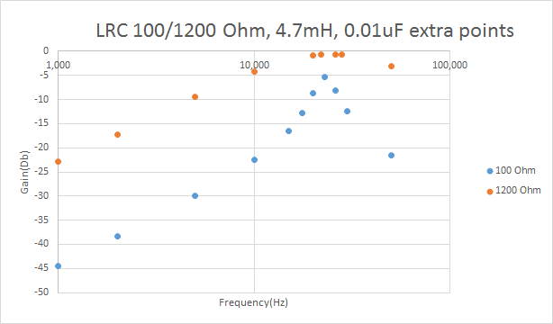
With these added points around the previous maximum, the graphs curves start to come out and a more visible peak can be seen which notably, is higher than that of the previous results (23KHz). From the graph, the peaks can be seen to be at the same frequency showing that the resistor doesn’t change the resonant frequency which works with the maths as $f_{o}=\frac{1}{2π\sqrt{LC}}$doesn’t contain R at all. The resistance only changes the width of the peak meaning a low quality which again works with the maths because when R rises the quality factor goes down $Q= \frac{1}{R}\sqrt{\frac{L}{C}}$.The gain in the circuit with
The larger resistance did have a higher gain over the resistor which is logical as if the capacitor and inductor have the same impedance as before the resistor has a higher percentage of that voltage over it compared to a lower resistance.

The resonant frequency, according to the graph, was 23KHz, before using this value the resonant frequency was checked by varying the frequency in smaller increments of around 0.1KHz until the voltage on the oscilloscope was at its maximum this occurred directly on the 23KHz point. At the resonant frequency (23KHz) the voltages $V_{i},V_{c},V_{l}$and $V_{r}$ were all measured.

F(KHz) | $V_{i}$ (V) | $V_{r}$ (V) | $V_{l}$ (V) | $V_{c}$ (V)
23 | 2.85 | 0.538 | 3.812 | 3.877

At the resonant frequency the voltages over the inductor and capacitor should cancel due to the current leading the voltage by ${90}^{o}$with the capacitors phase shift and voltage leading the current by ${90}^{o}$with the inductors phase shift. As these phasors are vectors with a ${180}^{o}$phase difference. If the reactances are equal then you will get 100% of the voltage over the resistor.
therefore at the resonant frequency $V_{i}=V_{R}$ and $V_{l}=V_{c}$
Strangely in this, our resistor doesn’t seem to be dissipating all of the energy.
With the 1200 Ohm resistor we should see the same pattern

F(KHz) | $V_{i}$ (V) | $V_{r}$ (V) | $V_{l}$ (V) | $V_{c}$ (V)
23 | 2.90 | 2.75 | 8.1 | 2.52
Oddly in this, the results do not resemble what they should or how the 100 ohm circuit acts as $V_{i}{≈V}_{R}$but $V_{l}≠V_{c}$for this to work smaller increments should be taken to find the resonant frequency to a higher degree of accuracy.
The value of Q can be estimated by 2 methods:
- $Q= \frac{f}{∆f}$
- $Q= \left|\frac{V_{c,l}}{V_{i}}\right|$
using equation 1 Q = $\frac{23}{50-12}=0.605$
using equation 2 Q = $\frac{2.52}{2.90}$=0.869
The reason it is better to use $V_{c}$ instead of $V_{l}$ is because in every circuit there is unwanted inductance, there was inductance in the lab where the experiment was carried out and impedance in the wires. Unfortunately from our results you can see that $V_{l}≠V_{c}$ and that makes me believe there is going to be a large gap between actual and calculated quality factor.
Using the equation
$$Q= \frac{1}{R}\sqrt{\frac{L}{C}}$$
Q = 0.517
Which is quite far from both calculated values so instead I am going to try with the 100 ohm resistor instead. Unfortunately due to the low resistance I cannot see this being much more accurate due to the smaller distance to measure with the same uncertainty , the inaccurate resonant frequency found and the fact the graph starts at -5Db and so the resonant frequency must be taken away from all results.
using equation 1 (must cross at -7) Q = $\frac{23}{25-22}$=7.67
using equation 2 Q = $\frac{3.88}{2.85}$=1.36
As expected these values are quite far away from the predicted this is obvious, from the results not following the expectations and rules, that this is a measurement error and not an error of the calculations as they are within the same powers.
L//C R 100/1200 ohm resistor, 4.7mH inductor, 0.01µF capacitor

100 ohm L//C R
F(Hz) | Vi | Vo | Gain(Db)
1,000 | 2.89 | 1.71 | -0.2279
2,000 | 2.89 | 1.63 | -0.2487
5,000 | 2.89 | 1.27 | -0.3571
10,000 | 2.89 | 0.74 | -0.5917
20,000 | 2.89 | 0.21 | -1.1387
50,000 | 2.91 | 0.66 | -0.6443
12,000 | 2.85 | 0.58 | -0.6914
14,000 | 2.83 | 0.49 | -0.7616
16,000 | 2.89 | 0.38 | -0.8811
18,000 | 2.89 | 0.28 | -1.0137
22,000 | 2.89 | 0.14 | -1.3148
24,000 | 2.89 | 0.1 | -1.4609
26,000 | 2.89 | 0.13 | -1.347
28,000 | 2.89 | 0.22 | -1.1185
30,000 | 2.89 | 0.22 | -1.1185
32,000 | 2.89 | 0.26 | -1.0459
34,000 | 2.89 | 0.33 | -0.9424
1.2K L//C R
F(Hz) | Vi | Vo | Gain(Db)
1,000 | 2.9 | 2.72 | -0.0278
2,000 | 2.9 | 2.69 | -0.0326
5,000 | 2.9 | 2.57 | -0.0525
10,000 | 2.9 | 2.37 | -0.0876
20,000 | 2.9 | 1.4 | -0.3163
50,000 | 2.9 | 2.67 | -0.0359
22,000 | 2.91 | 0.86 | -0.5294
24,000 | 2.91 | 0.49 | -0.7737
26,000 | 2.91 | 0.7 | -0.6188
28,000 | 2.93 | 1.23 | -0.377
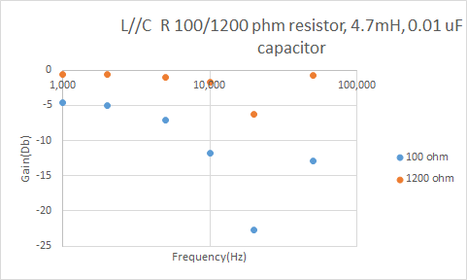
With the initial results, there is a lack of detail in the curve, with such large gaps we cannot tell the peak of the curve nor the curves shape. Due to this more points must be taken, as it would be good to see the curve added points taken from 10k-30k (Hz) with 2k(Hz) period on the 100 ohm graph and larger period on the 1200 ohm resistor due to the lack of need to look at the curve of the graph as we already have that for the 100 ohm.
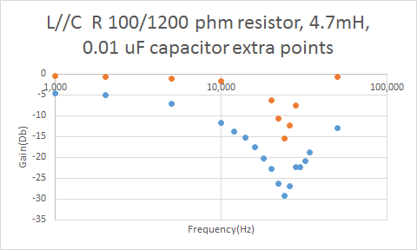
Now with the added points the curve can be seen to peak at 24 KHz and curve gradually up to that point. Now we can see that at 28KHz there is a strange point which seems to be the same as the next, this is possibly a writing down error or this could be actually what the reading said, due to this a secondary result was taken for this point ($V_{o}$=0.17) which when plotted looks a lot more realistic
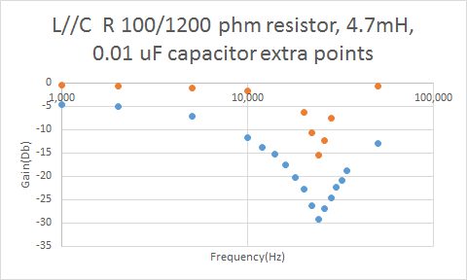
This point fits a lot better with the curve which makes me believe the last point was a copying down error especially as 28k and 30k results were exactly the same.
With this graph the resonant frequency is at 24KHZ, the point 23KHz should’ve been taken as a result as this was taken as the resonant frequencies in the previous with the same components.
graphically Q =$\frac{24}{26-22}$=6
manufacturer's values using $Q=R\sqrt{\frac{C}{L}} Q=100×\sqrt{\frac{0.01×{10}^{-6}}{0.0047}}$ =0.146 Fix this and talk about

Discussions
These results show that for the equations are much more accurate than that of taking physical measurements as you must find the resonant frequency to such a high degree of accuracy, it would be better to use the equations to find the resonant frequency and then take measurements at this frequency to test the effectiveness of the equations, especially if needed in an engineering application. For the first two tests a breadboard was used to find the results and with such large capacitance and inductance and even resistance using that system the results will be out from the actual, this created a large error in the system. In the next set of results the components were directly soldered to each other removing the unnecessary error. Unfortunately with the oscilloscope taking the measurements error can be induced as the oscilloscope cannot tell the difference between the signal and noise whereas we can see it, while trying to take the results with as little interference as possible and trying to cover for it there is still error due to this. With rise and fall time the oscilloscope is trying to do lots of measurements as of this one error is then multiplied three times and so I have little faith in those answers especially as they were taken while the components were in a breadboard and when taking these results some quite obvious ringing in the signal. As inductance is very dependent on the environment as it creates and interacts with fields which of course are in large quantities in a room with ring mains and each desk running many appliances at once and every wire in the circuit is also acting as an inductor. One of the largest sources of error was due to large increments in frequency to find the resonant frequency meaning the frequency at which the resonant frequency was measured at could’ve been out by up to 500Hz. Unfortunately, because of all of these errors I find it difficult to conclude how accurate the theoretical is to the actual. From this though we can look into why the circuits act the way they do, there are many different representations including phasors, vectors and complex number representations.
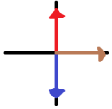
The circuit at every point can be exampled by a phasor/vector/complex diagram as such:
Where
Red = $V_{l}$
Blue = $V_{c}$
Brown = $V_{r}$

As V is directly proportional to reactance and resistance this can also be written as
Red = $X_{L}=2πfL$
Blue = $X_{Lc}=\frac{1}{2πfL}$
Brown = R
If we then use this as a graph of imaginary and real we can define the total impedance as $X_{T}=X_{l}+X_{c}$ but as $X_{l}=jωL$and $X_{c}=\frac{-j}{ωL}$ and we can say that $X_{lT}=R+ j(ωL-\frac{1}{ωC})$ [4]
as vectors, we can do this as $\sqrt{R^{2}+{(V_{l}-V_{c})}^{2}}$because they are at right angles and form a right angled triangle.
In the resonant circuits as the frequency in the circuit increases the impedance of the capacitor decreases and the impedance of the inductor increases meaning at a frequency the two impedances will be equal. At this point because the two phase shifts are opposite the voltages across them should cancel out to zero meaning $V_{i}=V_{r}$so in a series circuit this is the point where the resistor has the highest voltage over it. in a parallel circuit the circuit then has equal current through the capacitor and inductor meaning the shifts again cancel when the wires join but this time this is when the resistor has the least amount of voltage over it as the inductor and capacitor section has it’s highest total impedance point but the shifts aren’t going into each other meaning they add instead of cancelling out. To improve this experiment pre-calculations should be made to calculate the resonant frequency so that the results taken are on the actual resonant frequency rather than nearby it as it makes a large difference in the measurements.

Conclusion
To conclude these results were not accurate enough to base the accuracy of equations off, to check this much more data points with much smaller intervals and possibly more accuracy in taking the results must be taken. Unfortunately not meeting that aim a deeper understanding of resonant frequency graphs has been made meaning that this lab did have some success.
References
[1] - Success in electronics, Tom Duncan, John Murray (1983)
[2] - Waveform generator manual- https://drive.google.com/file/d/0B6cpHcPIVsD_SWRTclYyYXFvUUU/view
[3] - Oscilloscope manual - https://docs.google.com/a/sheffield.ac.uk/viewer?a=v&pid=sites&srcid=c2hlZmZpZWxkLmFjLnVrfGVsZWN0cmljYWwtY29udHJvbHMtbGFifGd4OjIyYTcxNmNhNjhmNmQ1NjU
[4] - RLC Resonant Circuits Andrew McHutchon April 20, 2013
put in circuit diagrams
Fix things in red

