Getting started
1.Log on:
First of all load up your PC and log on
2.Load up Arduino:
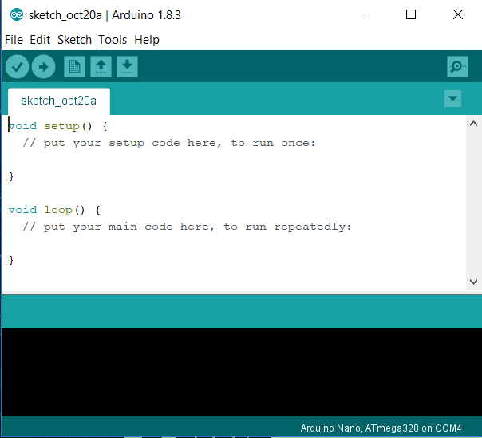
When you’re on the main screen search in the bottom left for “Arduino” if nothing comes up open the software centre program on your desktop and search in available software for Arduino and pick the bottom one with the short name. When this has finished try again to search in the bottom left bar for Arduino and it should come up otherwise open up software centre again and check if it has finished installing.
3.Setting up the IDE
You should now be faced with a screen like this one:
You can plug in your Arduino using the yellow cable in your box connecting the USB B to any USB port on your PC. Once this has been done and you’re on the software under tools make sure the board is set to Arduino Uno, if not set it. Now go under that and click on ports and you should see one port which has your board connected to it (says uno next to it) this is usually COM4 but just make sure it’s selected correctly.
4.Done!
You are now ready to start programming your device

