Flashing LED
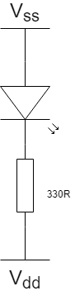
1.Setup the hardware:
You should already have you Arduino plugged in and ready to receive a program so let’s set up the hardware. First have a look if you don’t know already how a breadboard works (There’s an image on the website) and where the wires connect to where. Once you think you understand build the circuit as shown left or follow the instructions below:
Plug in a LED remembering which leg is positive (The longer one). The connect a wire from the positive leg to a digital pin on the arduino and a 330/270 ohm resistor (See the resistor chart) from the negative leg to ground(GND on the board).

2. Programming
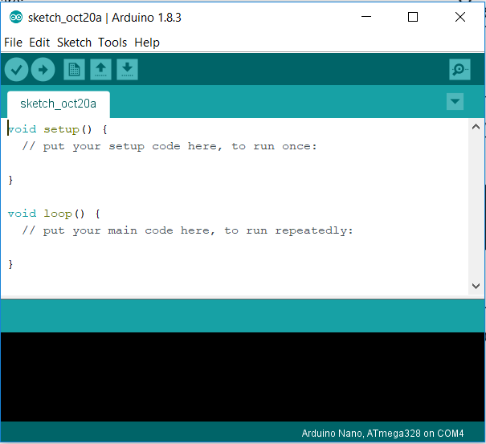
You should already have this screen up and ready to program on your PC, if not look back at sheet 0 to set it up.
Next we need to define the pin we are going to use to output our digital(on or off) signal to the LED. The pin you connected your positive led leg to is what you should use (I used 10).We define our pins by using the command : pinMode(10,OUTPUT)
You should put this in the setup section, this just tells the board to get pin 10 ready to output.
Next we need to define a variable which is just something we will use to know if the LED is on or off I’ll call mine litUp and is defined outside both the setup and loop by:
Int litUp =0;
I have just initialised mine with the value 0 so our led starts off as low(off). The int section simply defines our variable as an integer meaning no decimal points which is ok because we are only interested in 1 and 0.
Next we need to write our actual functioning code and we want this to run forever until we turn the power off so we write this in the void loop section
So first of all we want to check if our LED is on yet or not so we use an IF statement like so:
if(litUp==0){
digitalWrite(10,HIGH);
litUp=1;
}
Now this may seem a little confusing so lets break it up.
The first line (if line) is just asking if our variable we defined is equal to 0 (== is used to ask and = is used to set) if our variable is equal to zero then it’s going to run the code within the brackets
The second line(digitalWrite) is doing exactly what is says and seems like it is writing our pin (10 in this case) to HIGH meaning on and this turns our LED on.
And finally below this line is setting our variable we defined to 1 so we know it’s on!
Simple now you know isn’t it!

Next we need to define what happens if our LED is on as we’ve only turned it on if it’s off up to now so we use a else case which simply runs another section of code if the if statement fails and is used like so:
else{
digitalWrite(10,LOW);
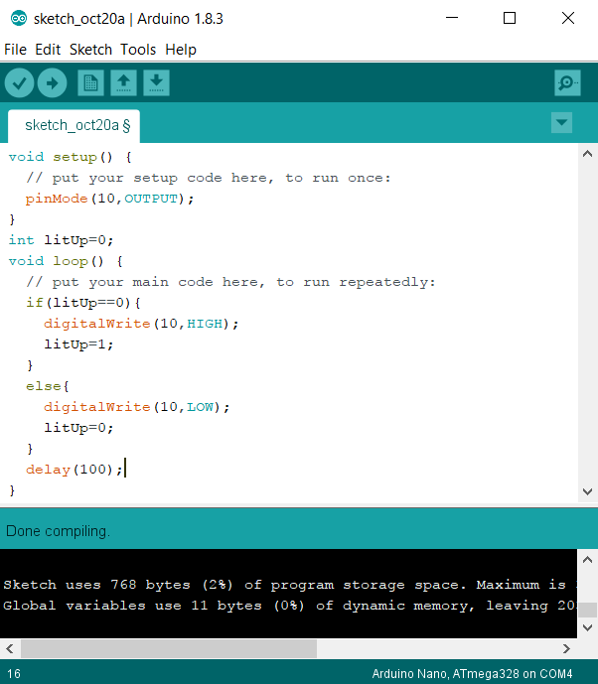
litUp=0;
}
This should make sense to you now and if not call someone over (especially me) and ask them to go through it with you.
Now all we need to do is add in a delay so that our program doesn’t run as fast as it possibly can this is done with
Delay(100);
Which just makes a delay of 100ms(you can change the 100)
3.Done
You should now be ready to compile and upload your program do this by clicking the tick button at the top left to check it works then the arrow button to upload it, if there are any errors ask someone over to help or check your code against mine shown below:
Once this is working try getting two LEDs flashing alternately!

