Basic oscilloscope
This is a very simple project and is only for you to get used to analogue reading and the serial plotter.

1.Hardware
We’re going to start off with the very basic hardware which for this is simply 2 wires one in an analogue port (I used A0) and another in ground. That’s it!

2.Software
When dealing with serial printing (sending data from the Arduino to the pc) we have to first establish a connection rate (generally 9600 is used) so first put “Serial.begin(9600);” into the setup section.

Now for the looping section, we’re going to want to read the value from our analogue pin and put it into the PC to read the data we use the line analogRead(pin) and to send it to the PC we use Serial.println(data) now try and bring the two together so you send the pin information to the PC.
Now this would work as it is but we are going to now add a delay but now very small just to stabalise the input frequency I used 2ms (once again try to remember these commands from memory).

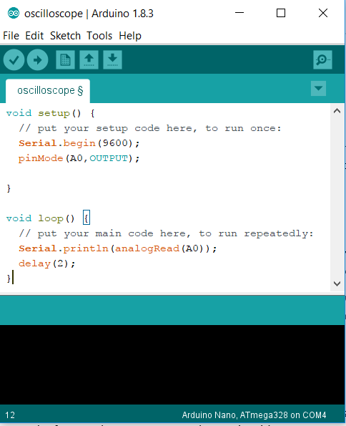
3. Done
Simple code, simple life! This is all the hardware and software done you should now have a functioning (positive only) oscilloscope. You can upload this and then go to tools and serial plotter and you can now see a graph of your voltages on your analogue pin with respect to ground (use the signal generator to make nice patterns or ask someone to set it up for you)

Code below for reference:

